Project Design Phase-II
Data Flow Diagram & User Stories

Date | 28-09-2026
Team ID | SWTID-2026-6939
Project Name | AI FitTrack API
Maximum Marks | 4 Marks

Data Flow Diagrams:
A Data Flow Diagram (DFD) is a traditional visual representation of the information flows within a system. A neat and clear DFD can depict the right amount of the system requirement graphically. It shows how data enters and leaves the system, what changes the information, and where data is stored.

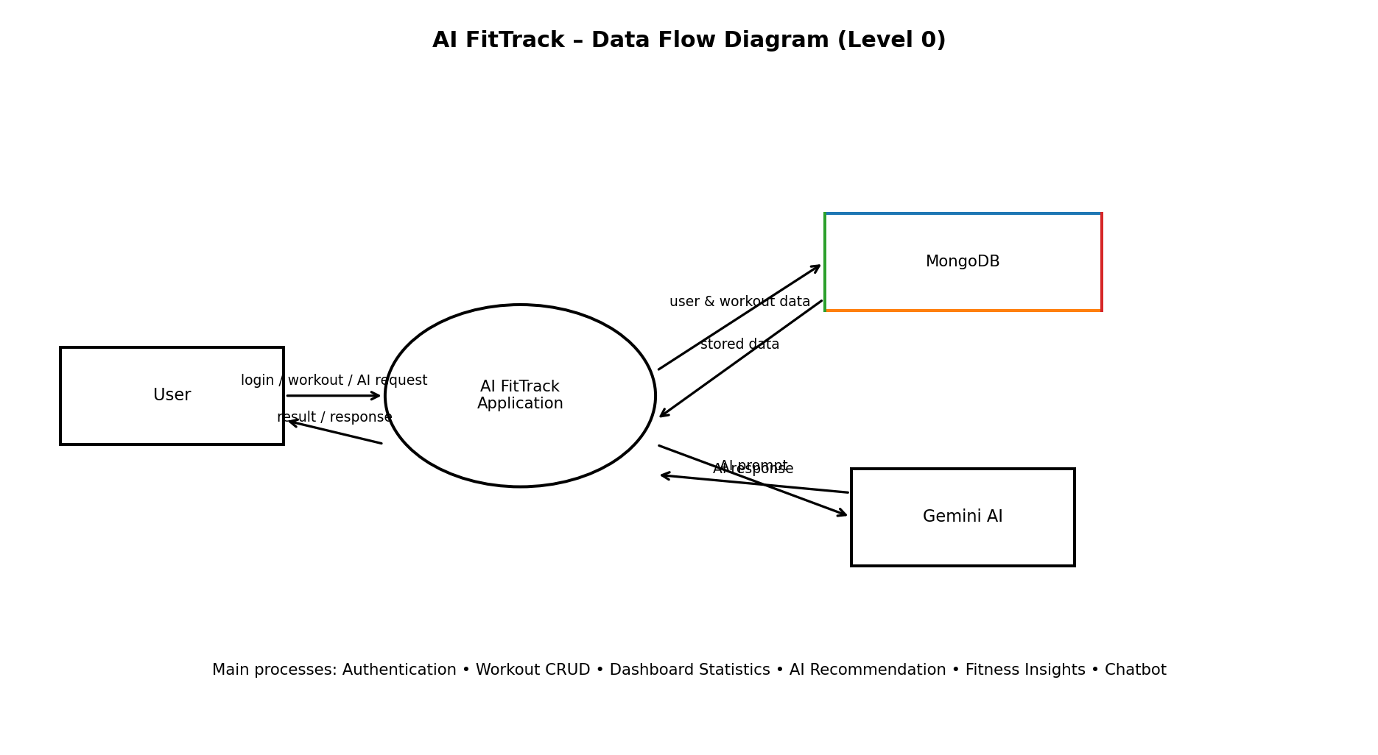
DFD Level 1: The user registers/logs in through the frontend; authenticated requests reach the workout and dashboard processes. Workout data is stored in MongoDB. AI recommendation, fitness insights, and chatbot requests are sent to Gemini AI and the generated response is returned to the user.
Example: (Simplified)


User Stories
Use the below template to list all the user stories for the product.
User Type | Functional Requirement (Epic) | User Story Number | User Story / Task | Acceptance criteria | Priority | Release
User | Registration | USN-1 | As a user, I can register with my name, email and password. | Account is created successfully and a JWT-capable user account is stored. | High | Release-1
User | Login & Authentication | USN-2 | As a user, I can log in using my email and password. | Valid credentials return a token and open the dashboard. | High | Release-1
User | Logout | USN-3 | As a user, I can log out of my account. | The stored token is removed and protected features are no longer accessible. | High | Release-1
User | Dashboard | USN-4 | As a user, I can view my fitness dashboard. | Dashboard displays total workouts, duration, calories, average duration and frequent category. | High | Release-1
User | Workout Management | USN-5 | As a user, I can add a workout with its name, category, duration and calories burned. | Valid workout is saved and linked to the logged-in user. | High | Release-1
User | Workout Management | USN-6 | As a user, I can view my saved workouts. | Only the logged-in user's workouts are displayed. | High | Release-1
User | Workout Management | USN-7 | As a user, I can edit or delete my workout. | The selected workout is updated or deleted successfully after ownership validation. | High | Release-1
User | AI Recommendation | USN-8 | As a user, I can receive a personalized workout recommendation using my age, goal and experience. | Gemini AI returns a practical workout recommendation. | High | Release-2
User | AI Fitness Insights | USN-9 | As a user, I can get AI insights based on my workout statistics. | Gemini AI analyzes workout totals and returns concise fitness guidance. | Medium | Release-2
User | AI Chatbot | USN-10 | As a user, I can ask fitness-related questions to the AI assistant. | The chatbot sends the question to Gemini AI and displays the generated response. | High | Release-2

